**Online Food Ordering System**  
Samarth Mule

# Abstract:

The **Online Food Ordering System**, developed using Django framework with python backend, streamlines the entire food ordering process. It caters to administrators, restaurants, customers, and delivery personnel. Administrators manage food categories, while restaurants register, add delivery personnel, and list their food offerings by category. Customers can browse menus, add items to their cart, and place orders. Delivery personnel are assigned to orders and can update delivery statuses. This comprehensive platform enhances efficiency and convenience in the food delivery ecosystem, benefiting all stakeholders.

# UML Diagram:

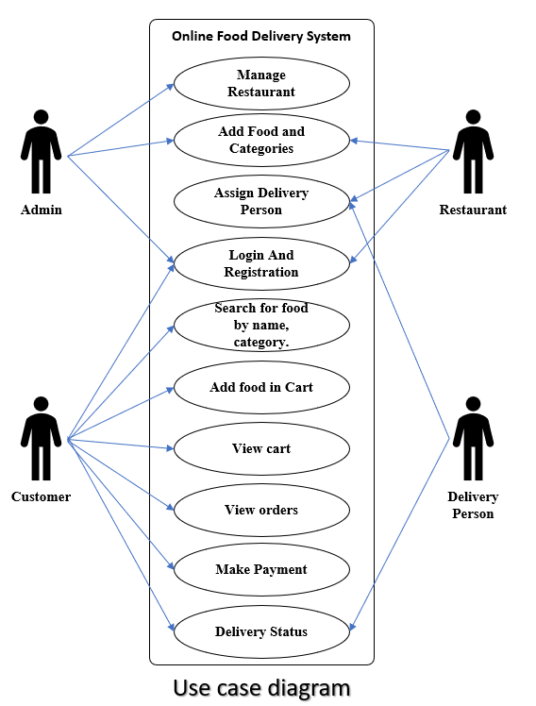

# Class Diagram:

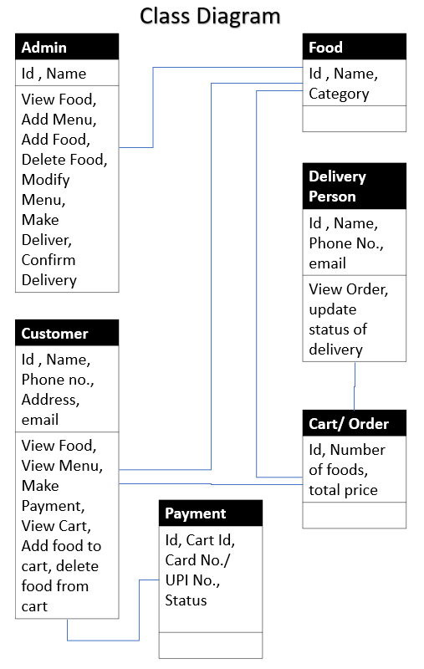

# Sequence Diagram:

# Data Flow Diagram (DFD):

# Technology Stack (Software Requirements):

## Software Requirements:

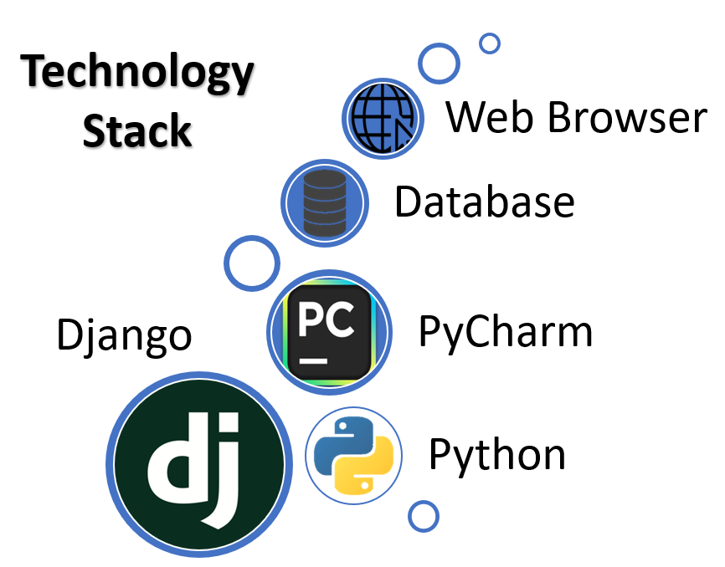1. **Python**: The project is developed using Python programming language. Ensure that Python is installed on the development environment.

2. **Django**: Django is the web framework used for developing the online food ordering system. Install Django using pip, the Python package manager.

3. **Database Management System (DBMS)**: Choose a suitable DBMS such as PostgreSQL, MySQL, SQLite, etc., supported by Django for storing application data.

4. **Integrated Development Environment (IDE)**: Any preferred IDE or text editor can be used for coding, such as Visual Studio Code, PyCharm, Sublime Text, etc.

5. **Web Browser**: A modern web browser like Google Chrome, Mozilla Firefox, or Microsoft Edge is required for testing and viewing the web application.

## Hardware Requirements:

1. **Computer**: A desktop or laptop computer is necessary for development purposes.

2. **Processor**: A processor with at least dual-core capability is recommended for efficient coding and testing.

3. **RAM**: A minimum of 4 GB of RAM is recommended for smooth development and testing processes.

4. **Storage**: Adequate storage space for storing project files, dependencies, and databases.

5. **Internet** **Connection**: An internet connection is required for installing dependencies, accessing documentation, and testing online features.

These requirements may vary depending on the scale and complexity of the project. It is essential to ensure that the hardware and software meet the minimum requirements for a smooth development and testing experience.